SABIC Company
Shatha Al Hejaili
170006678
Saudi Electronic University and Colorado State University- Global Campus
Dr. Ruth Holden
12-10-2019

Introduction
SABIC relates to industrialized Saudi company that is known for the production of petrochemicals, chemicals, metals, fertilizers and industrial polymers. The company is located in Middle East countries; it is the largest public company. It is among the largest company’s that produce a chemical product in the region. Currently, the company specializes in the production of ethylene glycol, and there are high chances of it becoming top after it creates some new products (source). The company is ranked as the second-largest manufacturer of polyethylene. The paper will analyze the organizational structure and the strategy implementation of the company.
SABIC is using a global transformation that is directed towards a more agile, cost-effective and customer-focused organization that meets its requirements more effectively (Lindsay, 2018). The company was supposed to establish the organizational structure by the beginning of the year 2016. The reorganization addresses the challenges that SABIC faces in the setting of the company's 2025 strategy that changes in the market landscape and also the need to drive innovation and technology. To achieve this, the company is using its existing portfolio while investing in the innovations that are needed for future growth (Hartnell, 2019).
There are several steps that SABIC Company employed towards the effective implementation of strategies (Lindsay, 2018). To ensure the successful implementation of policy, it is wise enough to have a system of how to go about it. The following are the steps to effective implementation:
The first step is Communication and Evaluation of the strategic plan in the organization. The strategic plan is beneficial when the company is at the Strategy stage (Lindsay et al. 2018). The plan should be evaluated, especially concerning the performance and initiatives. There are many inputs in the company that might emerge during the assessment that was not included in the strategy formulation stage (Lindsay et al. 2018).
The second step is the improvement of the implementation structure of the company. Creating a clear vision will give a direction for the implementation of strategies of the firm. The company established coordination methods between the different departments and their related units. The company also formulated the plans and procedures that usually guide the implementation of various strategies of the company (Lindsay et al. 2018).
Improvement of implementation support programs and policies. These are policies that SABIC Company employed towards the implementation (Lindsay et al. 2018). The company created a foundation for assessing the process of the implementation of strategies and also attaining results. In the creation of the reward structure, the company ensured a direct link towards accomplishing the results.
Budgeting and allocation of resources. The company had come up with budgets whereby the implementers of the strategy were given tools towards budgeting and distributing resources equally to all the departments. Resources would be allocated according to the results after the financial evaluation concerning their budgets. The disbursement of the resources necessary to every department and to ensure that everything was correctly and accurately recorded (Lindsay et al. 2018).
Discharge of activities and functions, the company used this stage to put the strategies into actions, using participatory management and the styles of leadership (Greer, 2017). In this step, the SABIC organization ensured constant engagement of experts by providing coaching and orientations.
A functional organizational structure is a structure that the SABIC Company used in its operations. Personnel with the same tasks were grouped based on their specialty (Ahearne, 2014). Workers dealing with accounting were taken to the finance department and others in their respective positions. This was to ensure that there was teamwork and making their chores easy in the company (Greer et al. 2017). This ensures that issues are handled by personnel who are fully qualified which later enhances the satisfaction and retention of customers. This also enhance competence of employees in the various departments in SABIC Company. This organizational structure suits SABIC due to the specialization of employees in different departments.
SABIC organization structure
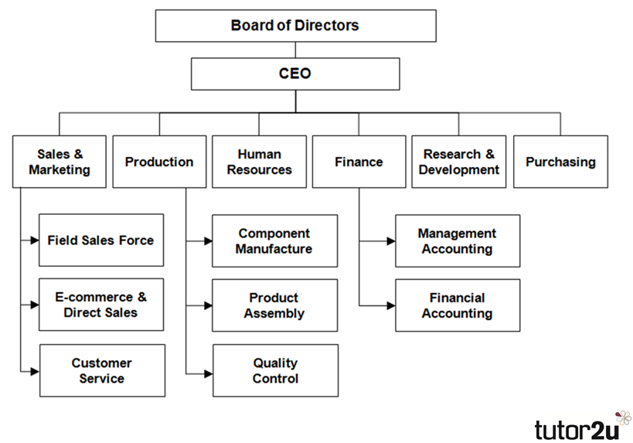

Specialization is a method of production in which there is a focus on the creation of limited goods to achieve great efficiency in production. Specialization mainly comes as a career of labor specialization. Specialization makes one different from the rest of the members. In SABIC Company specialization was applied in the distribution of various tasks (Lindsay et al. 2018). Coordination and cooperation ensure that there is unity in the company and every employee is doing what he or she is supposed to do. Cooperation also results in to increase productivity among employees in the company; hence, the company can produce more and quality products (Ahearne, 2014).
According to Goffins (2016), there are several ways companies successfully implement their strategies. Below are the ways to successfully implement these strategies:
Communicate and align. CEOs need first to communicate their aims or objectives which are stated by the values and vision of the company. The advantage of having great goals together with the firm objectives is that it creates a clear direction that acts as the basis of business planning and expansion. All the work of the employees should follow the purposes of the company and the vision of the CEO for the company (Greer et al. 2017). Drive and accountability, the CEO is the first person to formulate goals and share the goals with the rest of the members of the company (Ahearne, 2014). The CEO is responsible for showing the rest of the employees how their work results in the success of the firm. This sharing of goals by the CEO motivates workers to share their goals and work together, thus creating teamwork in the company. When a CEO is aware of the purposes of all employees and all employees are accountable for their goals, it makes it easy to compute strategy and vision (Ahearne, 2014).
Be action-oriented; there is a need for employees to be focused and know the physical actions that will result in the progress of the company goals and the managers need to cater to this process (Greer et al. 2017). The focus of every person should aim at specific tasks they need to attain to push these goals, and these goals need to match with the vision of the CEO. Track progress, there should be regular meetings that should be held with each team and discuss their progress. In this manner, everyone will come to know their contributions to the company play out when there are weekly meetings, and there will be clear communication lines to get everyone on track (Greer et al. 2017).
The following are keys to strategy implementation success:
Measurement. Key features visualizing strategy need to be tracked through the use of easily understood KPIs. A set of KPIs may be organized in a dashboard so that the company may determine progress (Hartnell, 2019). There should be business information to implement the strategy and measure the progress.
Tracking. Keeping records on the progress of the company's strategy is primarily to ensure that the company is on the right track and to maintain performance aligned with the vision (Lindsay et al. 2018). The company should understand its goals before establishing any strategy to be on the right track of achieving its goals. Reporting, tracking helps the company to have reports ready for members of the board (Lindsay et al. 2018). All the projects on progress should be captured during the implementation of the strategy to ensure that all the workers are well located in their positions. Reporting helps the company to save time while telling its history. Proper management, the team of the company is what drives the company to strategic success, and it is essential to develop the team and keep them tied to the goals of the organization (Lindsay et al. 2018). The company should provide employees with training and get feedback so that they can understand how their duties contribute to the achievement of the organization.
Lack of resources is the first problem of implementation. The costs of implementing a new strategy involve members of the board that provide training and also the cost of the change in technology (Lindsay et al. 2018). Lastly is the lack of enough communication; in every organization, communication is key to the implementation of the organization strategy. The company should use an effective communication plan to avoid the consequences of poor communication. Honest communication is both an effective organization and an essential step for any rollout. Lack of communication can result in widespread uncertainty (Lindsay et al. 2018).
Conclusion
The paper has discussed the organizational structure and strategy implementation of the SABIC Company. The paper has also analyzed the role of specialization, cooperative and coordination and how the company will identify the main strategy implementation success. Finally, the SABIC Company has done a lot in maintaining its competitive position as the fourth leading company in the world. It has applied many strategies to maintain this position. The leadership and the organizational structure of the SABIC Company were stable, and the employees are productive.

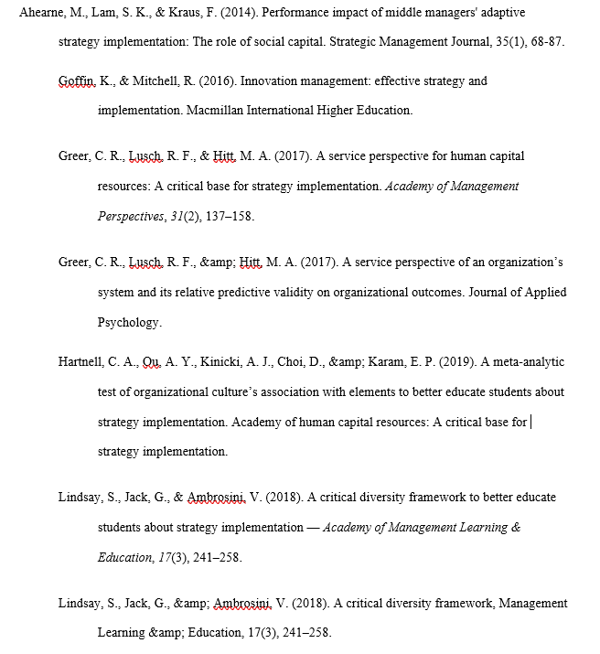
References

